Project Title: Commerce Web App
Start Date: 02/11/2020 | End Date: 3 months after the start date
Project Manager: Mariam Habib
Project Sponsor: Commerce Bank
Customer: Commerce Bank
Users: Commerce Bank customers
Stakeholders and Expectations:
Commerce Bank: expects a working application that meets the requirements, goals, and constraints.
Commerce Bank customers: expect an easy to use, aesthetically pleasing application that does what it needs them to do.
Professor Bingham: expects project to meet requirements and be turned in on time
Team: Have ready access to individuals with the authority to make decisions regarding software requirements
Purpose (Problem or opportunity addressed by the project): The purpose of this project is to provide Commerce Bank customers with a web application that pulls in transaction details and allows users to set triggers for notification rules and receive notifications around them. The system should also save data to a database so recurring reports can be created.
Goals and Objectives: The goal of the project is to create a web application so commerce bank customers can see their transactions in detail, receive notifications from the app, and the system should be able to save the data to a database. More specifically:

- Use Commerce Bank color scheme in styling
- Session for remembering user if they close their browser and then log in again

Major Milestones and Deliverables:
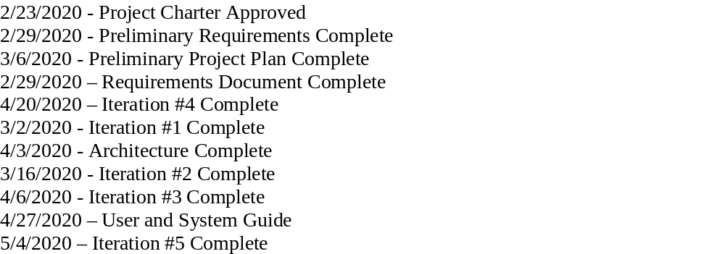
Success Criteria: The overall project will be deemed a success if the product success criteria are met by meeting all the constraints, goals, and stakeholder’s expectations on time. The product should have a dashboard that tells a user the number of times each notification rule has been triggered over the past month and year, the ability to hide notification rules when the times tripped is zero, the ability for users to choose a date range view the data, the ability for a user to create a login with a username and password that is at least eight characters, contains one upper case letter, one symbol, and one number. The transaction list should be sorted by date, users should have the ability to add transactions, there should be a trigger tool to allow for configurable notification rules to be created to notify users when transactions fit into a set of criteria, and users should receive notifications when they log in.
Scope: The software will allow users to login to the web application, set notifications, and view transaction details by date. Our software will need at least 10% code coverage for unit tests.
- Must be a web application built in a .net framework
- Application must be responsive and aesthetically pleasing
- Use .net framework for client-side framework/libraries
- Database used will be SQL Server
- Cannot use external resources
Risks and obstacles to success: The programming staff doesn’t have any experience with .net or react. Some members are unfamiliar with C#, SQL, JavaScript, and HTML. Time will also be an obstacle as we only have 3 months to complete the project.
Signatures
__________________________________
Project Manager
__________________________________
Project Sponsor
__________________________________
Customer
__________________________________
Technical Lead

